Miscellaneous

The Science Media Center Germany
www.sciencemediacenter.de
https://www.sciencemediacenter.de/en/smc/smc/

(self definition!):„We are a journalistic, independent and non-profit institution. Our team supports journalists free of charge in reporting on science-related topics. Our goals are laid down in our articles of association.
With a constantly growing network of currently more than 1,000 contributing researchers, we currently support over 1,600 accredited journalists in their reporting - with expertise from the sciences. We deliver evidence and facts from the sciences. And we do so independently, quickly and reliably.
Especially when current events are related to scientific expertise or new research results cause a public stir, journalists are faced with considerable challenges:
- Where to find reliable expertise in the sciences in a timely manner?
- Where to get expertise from willing researchers for quotes or additional information?
- How to find rational arguments in polarised debates?
This is exactly where our work begins.“

Himalaya:
https://www.himalayandatabase.com/
The Himalayan Database is a compilation of records for all expeditions that have climbed in the Nepal Himalaya. The database is based on the expedition archives of Elizabeth Hawley, a longtime journalist based in Kathmandu, and it is supplemented by information gathered from books, alpine journals and correspondence with Himalayan climbers

CIA Factbook:
https://www.cia.gov/the-world-factbook/
https://www.cia.gov/the-world-factbook/countries/moldova/

Action Network:
WorldbeyondWar.org – a global movement to end all wars
https://worldbeyondwar.org/

DE
Information about companies: see particular data sheet

Access to information of authorities:
either directly
or (for instance) via
https://fragdenstaat.de
Further details will be given by Aiko KEMPEN (Monday, Dec 5th)

EU

Access to EU-files: all EU-Institutions incl. Transparency Register
DE: https://european-union.europa.eu/principles-countries-history/principles-and-values/access-information_de
EN: https://european-union.europa.eu/principles-countries-history/principles-and-values/access-information_en
MD-RO: https://european-union.europa.eu/principles-countries-history/principles-and-values/access-information_ro

RO: https://ec.europa.eu/search/?queryText=Dokumentenzugang&query_source=europa_default&page=&filter=&swlang=ro&filterSource=europa_default&more_options_date=*&more_options_language=ro&more_options_f_formats=*

Transparency Register oft he EU: ca. 12.500 registered Organizations
EN
https://www.europarl.europa.eu/news/en/headlines/eu-affairs/20180108STO91215/transparency-register-who-is-lobbying-the-eu-infographic
RO
https://www.europarl.europa.eu/news/ro/headlines/eu-affairs/20180108STO91215/registrul-de-transparenta-grupurile-de-interese-din-ue-infografice
DE: https://www.europarl.europa.eu/news/de/headlines/eu-affairs/20180108STO91215/transparenzregister-mehr-klarheit-uber-lobbyarbeit-bei-der-eu-infografiken

EN: EU-Access via www.FragdenStaat.de:
https://fragdenstaat.de/en/help/eu-foi/

The European Environmental Agency – EEA
EN: https://www.eea.europa.eu/
RO. https://www.eea.europa.eu/ro
The European Information and Observation Network (Eionet) i spart of EEA:
information related to
chemical monitoring
fresh water
climate and energy
industrial emissons and others

Statistical Database „Eurostat“
https://ec.europa.eu/eurostat
„The home of high-quality statistics and data on Europe“ (self-definition“). Available not in Romana, but English

„Umwelt-Informations-Gesetz (UIG)“: Environmental Information Act (refers to all EU-Countries):
https://eur-lex.europa.eu/legal-content/DE/ALL/?uri=celex%3A32003L0004
bzw
https://eur-lex.europa.eu/legal-content/RO/ALL/?uri=celex%3A32003L0004
bzw
https://eur-lex.europa.eu/legal-content/en/ALL/?uri=celex%3A32003L0004

European Court of Human Rights - ECHR:
www.coe.int
Search for court decisions:
https://publicsearch.coe.int/#k=#f=%5B%5D

LobbyFacts.eu
https://www.lobbyfacts.eu/

USA
Freedom of Information Act (FOIA): refers to (nearly) all documents of federal authorities
https://www.foia.gov

Open Secrets:
https://www.opensecrets.org/

You can also ask the CIA or the FBI:
https://www.cia.gov/readingroom/
https://www.fbi.gov

In the US security of personal data is much less earmarked. Therefore exist a lot of providers of such information drawn from all publicly accessable sources . But chargeable:

Spokeo. Know More.
www.spokeo.com/
The database collects everything from across the U.S. that is publicly available in other databases and other sources, including social media, and brings it together centrally in its own database.

Possible alternatives to be tried on a case-by-case basis:

www.pipl.com
www.truthfinder.com
www.ussearch.com
www.intelius.com
www.instantcheckmate.com
www.peoplefinder.com
www.whitepages.com
www.beenverified.com

Court Files in the US
Because oft he Freedom of Information Act (FOIA) court files are transparent and accessable für everyone. The following link is provided by the Federal Government and refers to trials pending before federal courts. Because oft he multirude of daily trials, such databases are incomplete.

Public Access to Court Electronic Records
https://pacer.uscourts.gov
It’s the official database of the US Federal Government

Possible alternatives to be tried on a case-by-case basis:

- Law Library
https://aclawlib.wordpress.com/2012/12/01/justia-dockets-filings-a-free-alternative-to-pacer-for-docket-research/

- Free Law / RECAP
https://free.law/recap

- PacerMonitor
www.pacermonitor.com

Other databases:

FAS – Federation of American Scientists:
https://sgp.fas.org
The Federation of American Scientists is a nonprofit policy research and advocacy organization founded in 1945 to meet national security challenges with evidence-based, scientifically-driven, and nonpartisan policy, analysis, and research.

Project on Government Secrecy:
https://sgp.fas.org/foia/index.html

LEAKING

Worldwide the first one was „cryptome“, launched 1996 (Wikileaks came 2010 with www.collateralmurder.com and other secret files, but is since November 2022 more or less down):
http://www.cryptome.org

Alexej NAVALNY and his supporters in RF:
https://fbk.info (fomerly: rospil.info)
https://fbk.info/?lang=en

ruleaks.net: temporarily (?) doesn’t work

https://balkanleaks.eu/
last entries dated 2018

International Tax Evasion/Tax Fraud of all sorts of „VIP’s“
You can go through serveral databasis emerged in the context of (actually) 6 leaks, provided by the International Consortrium of Investigative Journalists (ICIJ): www.icij.org:

- https://offshoreleaks.icij.org (2013)
- https://www.icij.org/investigations/luxembourg-leaks/ (2014)
- https://www.icij.org/investigations/swiss-leaks/explore-swiss-leaks-data/ (2015)
- https://www.icij.org/investigations/panama-papers/ (2016)
- https://www.icij.org/investigations/paradise-papers/ (2017)
- https://www.icij.org/investigations/paradise-papers/ (2021)

Climate Change

Science Based Targets:
https://sciencebasedtargets.org/reports/sbti-progress-report-2021/progress-data-dashboard

CDP – Disclosure Insight Action:
https://www.cdp.net/en/info/about-us/disclosure/disclosure-insight-action

Global Oil and Gas Exit List:
https://www.urgewald.org/global-oil-and-gas-exit-list

Climate Action:
https://www.climateaction.org/

https://theelders.org/programmes/climate-change?gclid=CjwKCAiAp7GcBhA0EiwA9U0mtswC-aRLOUiQYl5byjpkpdOa6U-B7VfB14CTfdNqti_ozJ5fl10gHRoCDGIQAvD_BwE

https://www.un.org/sustainabledevelopment/climate-change/

climate action 100:
https://www.climateaction100.org/

OSINT

https://osintframework.com/
all selectable bullet points are active:
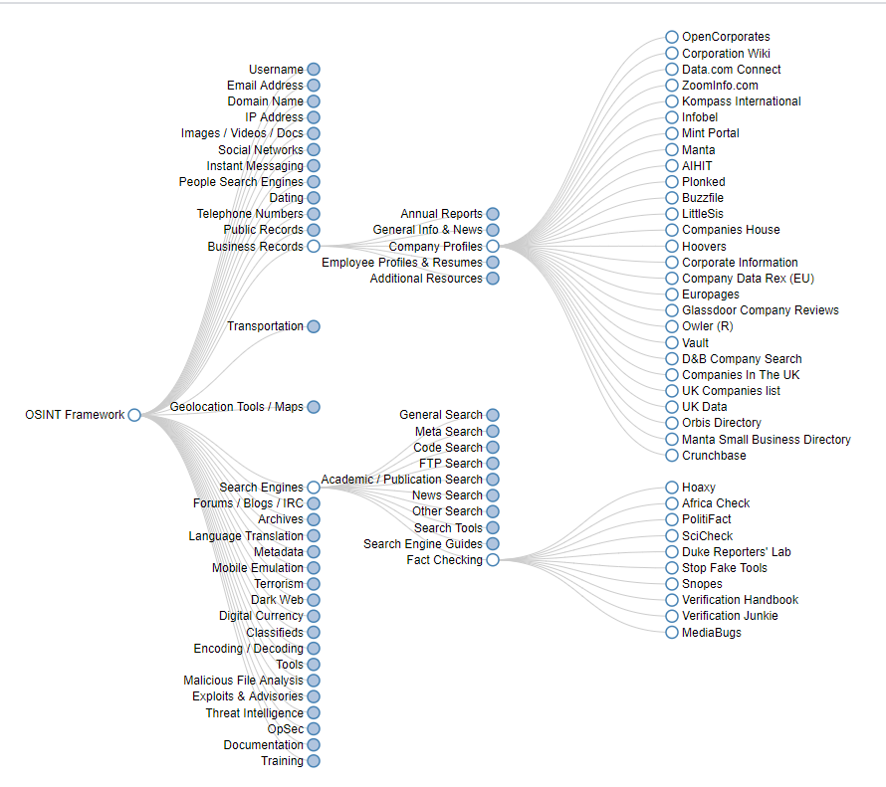

Computer Chaos Club: www.ccc.de
Video „OSINT for everyone“:
https://www.youtube.com/watch?v=8E6u1e3jq74 (translated in EN)

other sources:
https://aware7.com/de/blog/open-source-intelligence-bei-instagram-mit-osi-ig/

www.osintgeek.de/tools
collection & survey on specific tools

The German Foreign Secret Service „BND – Bundesnachrichtendienst“
explains (EN) OSINT, HUMINT, IMINT, SIGINT, GEOINT etc:
https://www.bnd.bund.de/EN/Home/home_node.html

data-journalism

DataJournalism.com
Created by the European JOurnalism Centre
There you can register here for a free member account and get free goodies: https://datajournalism.com/register
important tool !

ICIJ: Nine Essential Tools
https://www.icij.org/inside-icij/2018/08/nine-essential-tools-from-icijs-data-journalism-and-programming-experts/

CIJ – paper ref. Investigative Data Journalism in a Globalized World.
A Survey Study on ICIJ Journalists, accessable at
https://journalistik.online/en/paper-en/investigative-data-journalism-in-a-globalized-world/

Bellingcat’s Online Investigation Toolkit
bit.ly/bcattools = https://docs.google.com/spreadsheets/d/18rtqh8EG2q1xBo2cLNyhIDuK9jrPGwYr9DI2UncoqJQ/edit#gid=930747607

GIS/GEOINT
https://datajournalism.com/read/longreads/geographic-information-systems-a-use-case-for-journalists

https://www.e-education.psu.edu/geog486/node/726 (case example: AirBnb)

EDJNet - The European Data Journalism Network
www.europeandatajournalism.eu/rum/ (RO)

++++++++++++++++

The following links are provided by the ntv-datajournalism-team: Martin MORCINEK & Christoph WOLF on Wednesday, Dec 7th:

Contact when questions arise or cooperations are required:
Martin MORCINEK, Redakteur Karten, Daten, Infografiken - martin.morcinek@ntv.de
Christoph WOLF, Redakteur Karten, Daten, Infografiken - christoph.wolf@ntv.de

Tools zur Visualisierung, online (selection)
- Flourish
- 23Degrees
- Tableau
- PowerBI
- Infogram
- Datawrapper (How-to’s, Tipps und Beispiele: Academy)
Datensammlung
- Google Tabellen (“Sheets”, “GDocs”)
- Formeln für GDocs

Datengewinnung
- Datenimport via Google: <IMPORT>
- Daten aus PDFs extrahieren: Tabula

Datenbereinigung
- Plain Text Editor: Sublime
- Bereinigen im Editor via Regex: RegEx

Automatisierung
- Python
- Jupyter
Karten
- OpenStreetMap (OSM, mit “© OpenStreetMap-Mitwirkende” frei verwendbar)
- OpenTopoMap (OTM, mit “© OpenStreetMap-Mitwirkende” frei verwendbar)
- Kartenelemente aus OSM und OTM extrahieren: Overpass
- Linien und Flächen für Dw-Karten erstellen: geojson io
- Flächen vereinfachen: Mapshaper
- komplexe Karten, Geo-Analysen: QGIS

Quellen (Beispiele)
- UN Data
- Eurostat
- Weltbank

